- Title: Platform Question 23 – Power of Two
- Platform: LeetCode
- Problem Number: 231
- Language: C
- Status: Accepted
- Problem Link: https://leetcode.com/problems/power-of-two/
Code:
bool isPowerOfTwo(int n) {
if (n <= 0) {
return false;
}

while (n % 2 == 0) {
n = n / 2;
}

return n == 1;
}
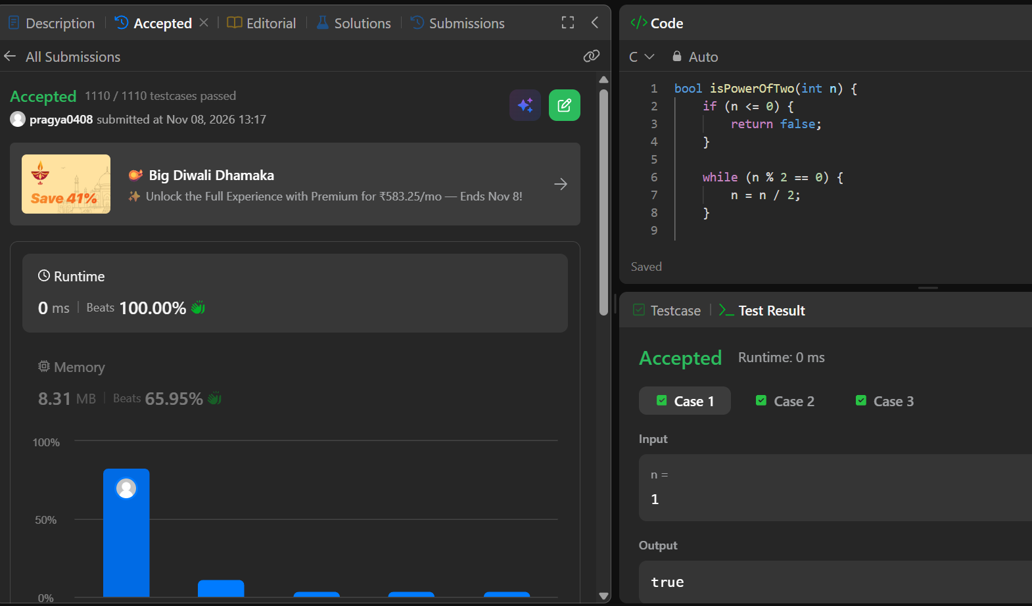leetcode_231_power_of_two

